
User Manual
Modality Emulator

Table of Contents

1 Introduction 5
1.1 Revision History 5
1.2 General 5
1.3 Summary 5
1.4 Key Features 5
1.5 Audience 5
1.6 System Requirements 5
1.7 Acronyms and Abbreviations 6
1.8 Glossary 6
2 Software Installation 7
2.1 .NET Framework installation (optional) 7
2.2 Modality Emulator installation 10
3 Modality Emulator – User Interface 13
3.1 File Menu 13
3.2 Help menu 13
3.3 Button bar 14
4 Configuration 15
4.1 Configure Remote System 15
4.2 Configure Emulator 17
4.3 Templates for Emulator behaviour 18
5 Perform DICOM actions 21
5.1 MWL - Worklist Query 21
5.2 MPPS – Modality Performed Procedure Step 22
5.3 DICOM Store 22
5.4 Storage Commit 23
6 Special usage 25
6.1 Extract the templates from a capture 25
6.2 Load the templates in the Emulator 27
7 Mapping information 29

Introduction

Revision History
Version | Author | Date | Description
0.1 | P.G. Brouwer | 13-10-2008 | First version of this document, describing the functionality of version 3.1.1.
0.2 | P.G. Brouwer | 28-10-2008 | This document describes the functionality of version 3.1.1.

General
The Modality Emulator software has been tested on a regular computer with Windows XP Professional SP3 loaded. For compatibility with other operating systems see the DVTk website.

Summary
The Modality Emulator can be used to emulate all the DICOM functions of a modality system. You can use it:
- To test and verify communication with all the DICOM services a real modality would use.
- Or if you want to test the interaction of your own applications services with a modality.
The detailed reporting gives you full feedback and analyses of all the communication.
It can use DICOM files as input for Queries, MPPS and Storage actions, allowing you to utilize your own real medical data.

Key Features
- TCP/IP Ping and DICOM Verification
- Query Modality Worklist
- Modality Performed Procedure Step updates
- Storage
- Storage Commitment
- Detailed results with data highlighting
- Validation of attribute mapping

Audience
Service engineers can quickly replace real modalities in medical environments with the emulator and verify the connectivity of all the DICOM services involved. Test engineers and developers can use it to emulate a medical environment for testing software products with complete workflow scenarios.

System Requirements
- Microsoft Window XP
- .NET 2.0 Framework

Acronyms and Abbreviations
Term | Meaning
IHE | Integrating the Healthcare Enterprise. For more information see
HIS | Hospital Information System
IHE | Integrating the Healthcare Enterprise
IOD | Information Object Definitions
MPPS | Modality Performed Procedure Step
MWL | Modality Worklist
NEMA | National Electrical Manufacturers Association
PACS | Picture Archive and Communication System
PPS / MPPS | Performed Procedure Step / Modality Performed Procedure Step
RIS | Radiology Information System
RSNA | Radiological Society of North America
SCU | Service Class User
SCP | Service Class Provider
UID | Unique Identifier

Glossary
Term | Meaning
Actor (IHE) | Actors are information systems or components of information systems that produce, manage, or act on information associated with operational activities.
Broker | One of the tasks that a Broker does is converting HL7 messages into DICOM messages. In this document the term RIS will be used, when actually the broker is mend, for two reasons:  - Modality manuals generally refer to RIS instead of Broker,  - The screens of the Modality Emulator also refer to RIS.  The MWL functionality is supplied by the Broker! See also: “5 Perform DICOM actions”
HL7 | Health Level 7. A compact language used in medical environment to transmit information.
IHE | Integrating the Healthcare Enterprise. For more information see www.ihe.net
RIS | Radiology Information System. RIS systems typically “speak” HL7. A new trend is “Brokerless”, which means that Broker functionality is integrated into the RIS system.
Template | In this document the term template is used to indicate a (part of a) DICOM that can be used to simulate the Modality Emulator behaviour.

Software Installation
The software installation procedure of the Modality Emulator application consists of the following steps:
- Installation of the Microsoft .NET Framework R2.0.
- Installation of the Modality Emulator application.

The installer checks the presence of .NET Framework 2.0. If this package is not installed, the following message will appear:

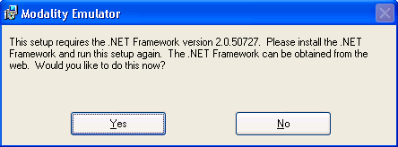

- Pressing Yes: The software will be downloaded from the Microsoft website and installed.
(This step requires an internet connection.).
- Pressing No: The installation will be stopped.

Important: Before starting with the Modality Emulator application installation, remove any previous installed version of the Modality Emulator application. Use windows “Add or Remove Programs” to remove the program.

.NET Framework installation (optional)
On the Microsoft website the executable for .NET Framework 2.0 can be downloaded. Use this method when no internet connection is available. The steps below guide you through the installation of .NET Framework 2.0.

When the .NET Framework installation is started, the following screen appears. | 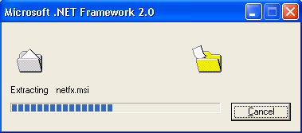
Press “Next” | 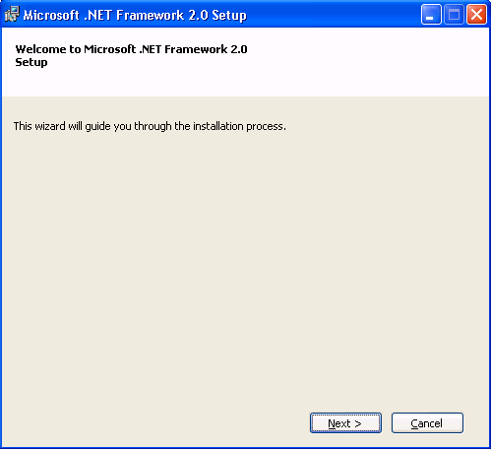
After reading the End-User License Agreement, tick the box “I accept the terms of the License Agreement”.  Press “Install”. | 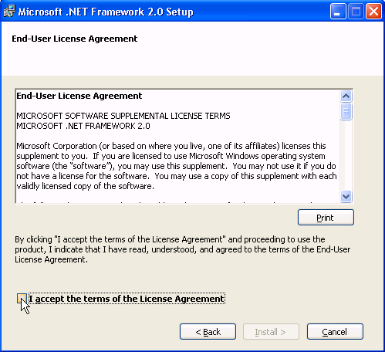
Time for coffee …. | 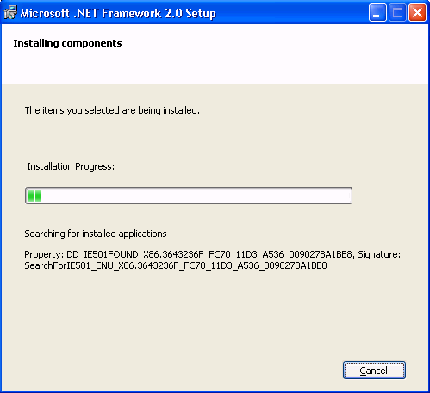
Click “Finish” to complete the .NET Framework installation. | 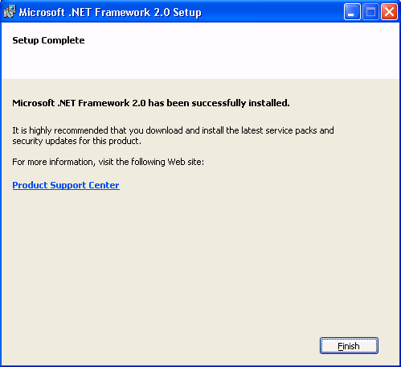

Modality Emulator installation

Click the Modality Emulator installation file to start the installation.  Press “Next”. | 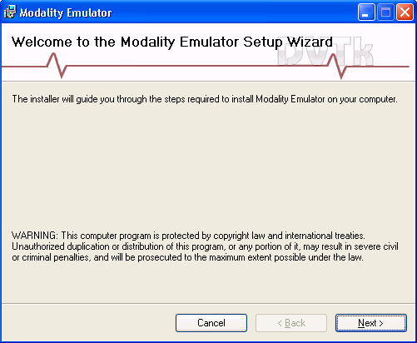
After reading the License Agreement, tick the box “I agree”.  Press “Next”. | 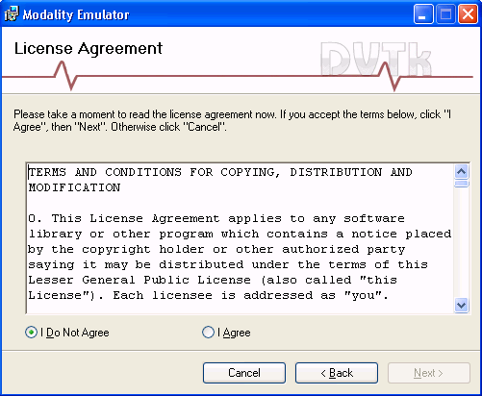
Keep the default destination for the place where the program will be installed.  Keep the default “everyone”.  Press “Next” | 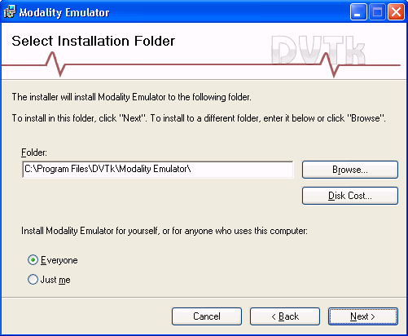
Press “Next” | 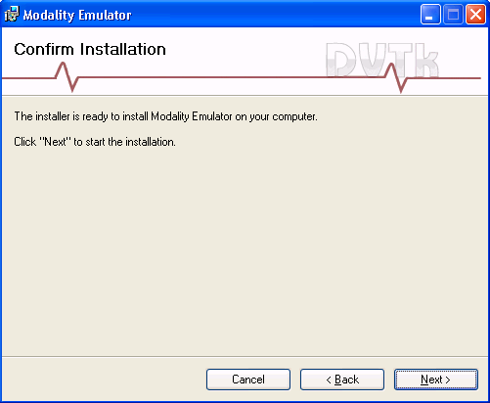
Another coffee … | 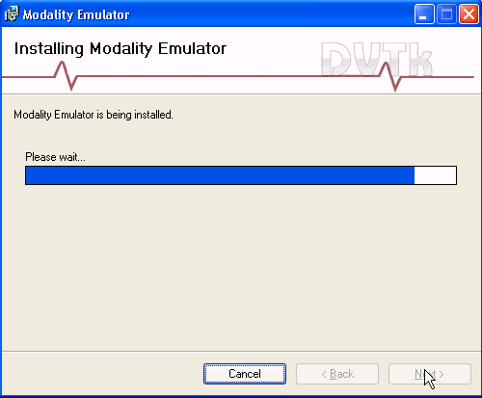
Press “Close” to complete the installation. | 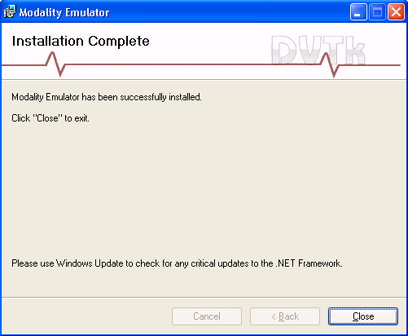

Modality Emulator – User Interface

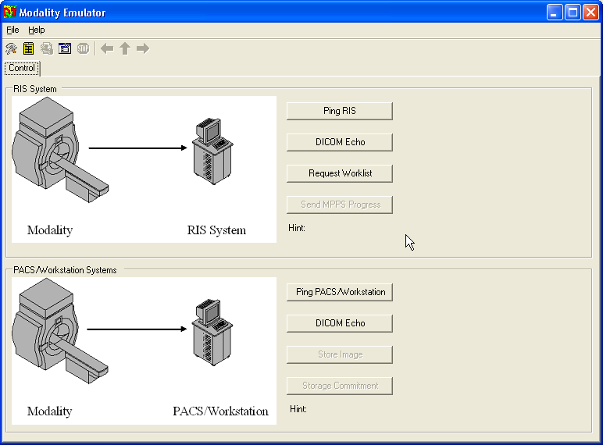

File Menu
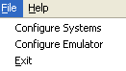 | Press “File, Configure Systems” to add an extra tab in the application.  In this Configure Remote Systems menu the various parameters are set to connect to the remote systems.
Press “File, Configure Emulator” to add several tabs in the application.
In these tabs various parameters can be set.
 | Press Exit to exit the application

Help menu
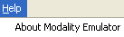 | 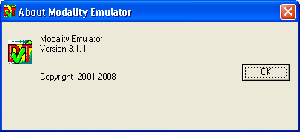  Press “Help” to view the version number.

Button bar
Just below the menu bar you can see the “button-bar”.

Icon | Meaning
 | Press this button to get the “Configure Emulator” tabs
 | Press this button to get the “Configure Systems” tab
 | Press this button to display the results
 | Press this button to get the tab “activity logging”.
 | To stop the emulator
 | Go Back (only applicable in “Results” window)
 | Go Top (only applicable in “Results” window)
 | Go Forward (only applicable in “Results” window)

Configuration

Configure Remote System
Use the Menubar or Buttonbar to open the Modality Emulator configuration. The screen as shown below will open:

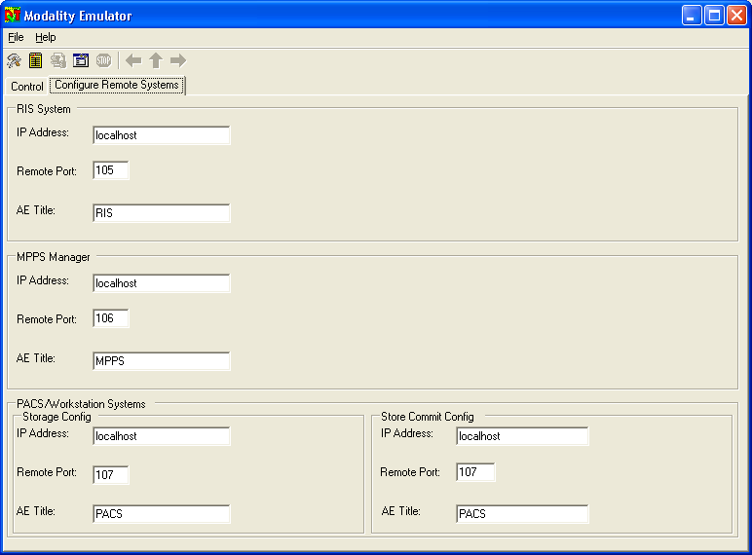

RIS System | Here you should read the Worklist provider. Mostly this is the broker that is connected to the RIS!  Enter correct IP-Address, Port number and AETitle.
MPPS Manager | The MPPS manager handles the MPPS messages. In most cases this is the same broker as described above, but using different AET/port.  Enter correct IP-Address, Port number and AETitle.
PACS/Workstation  Systems | The location where the images will be stored.  Enter correct IP-Address, Port number and AETitle.
Store Commit Config | When the store location above is the PACS, a Storage Commit can be requested. Enter correct IP-Address, Port number and AETitle.

When the IP-Addresses, Port-Numbers and AET’s have been entered, the connections can be tested. Go to the tab “Control”.
In the area RIS System:
- Press the button Ping RIS. When the text “Ping Successful” is displayed, the TCP/IP connection between Modality Emulator and RIS is OK.
- Press the button DICOM Echo. When the text “DICOM Echo Successful” is displayed, the DICOM association (“DICOM Ping”) between Modality Emulator and RIS is OK.

In the area PACS/Workstation Systems:
- Press the button Ping PACS/Workstation. When the text “Ping Successful” is displayed, the TCP/IP connection between Modality Emulator and PACS/Workstation is OK.
- Press the button DICOM Echo. When the text “DICOM Echo Successful” is displayed, the DICOM association (“DICOM Ping”) between Modality Emulator and PACS/Workstation is OK.

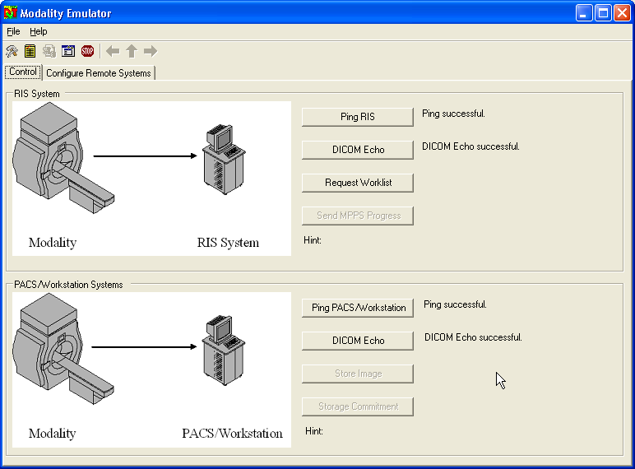

Experience based tip: When the settings have been made, and the “ping” and “DICOM echo” was successful, close the program, followed by restarting the program. Why? Then the settings are stored. If you would have to kill the program, non-stored settings are lost.

Configure Emulator
Use the Menubar or Buttonbar to open the Configure Emulator tab’s. Select the tab “Configure Emulator”. The screen as shown below will open:

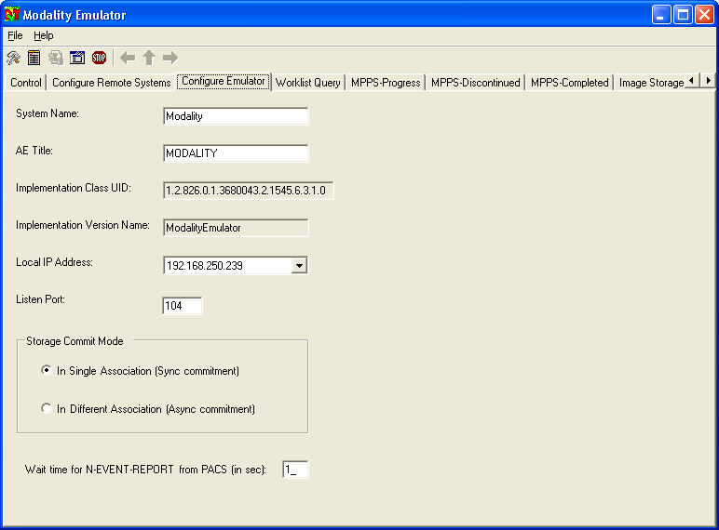

System Name | Although this name is not so important, some remote systems use the combination System Name and Local IP-Address as authorization to allow access.
AE Title | The name that will be used in the association negotiation. Most systems require that this name is known/configured in the remote configuration.
Local IP Address | IP-Address of the computer that runs the Modality Emulator application. The default entry is taken from the network settings. Only when more network cards are used, make sure the correct address is selected.
Listen Port | The port on which the Modality Emulator application can receive a DICOM association.
Storage Commit mode. | Single association: The connection between the Emulator and the PACS remains open for the N-Event-Report, unless the wait time has elapsed.  Different association: The connection between the Emulator and the PACS will close directly after the Commit request. The PACS will open a new association to sent the N-Event-Report.
Wait time for N-Event-Report. | When this time (in seconds has elapsed) the association will be closed.  Only applicable for single association Storage Commit mode.

Templates for Emulator behaviour
The function of Modality Emulator Application is to emulate a modality, what a surprise! But the program is doing this in a very smart way! As can be seen in the screenshot below, several tab’s exist for configuring the behaviour of the emulator. When the system has queried for a specific patient, the MPPS and Store templates will be modified to match patient demographics.
For details about mapping see paragraph: 7 Mapping information.

Workflow Query template

When the Worklist Query tab is pressed, the screen at the right is shown:  - The left-hand top side is showing the directory where template files are located. The screenshot shows the default location for the template files. The program will remember the directory where the template was last loaded.  - The left-hand bottom side is showing the selected template.  - The right pane of the screenshot shows the tags. | 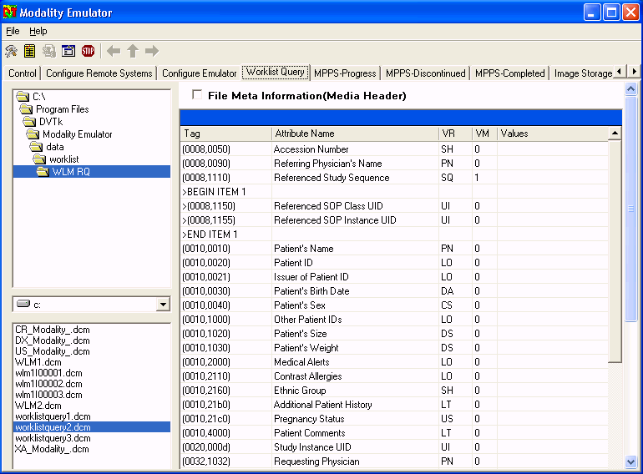
Load the template that matches your use. The values can be changed by clicking in the “value” column, enter the value that should match. Confirm by pressing the enter button.

When no connection is made to a RIS, the “Dummy Patient” can be used. The values of the Dummy Patient can be configured in the Dummy Patient tab. | 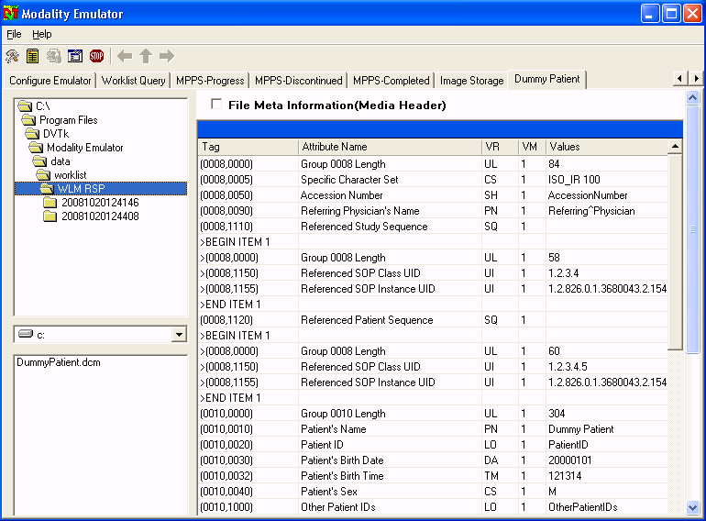  Dummy Patient tab

MPPS – Progress template
When the MPPS Progress tab is pressed, the screen at right-hand side is shown:  - The left-hand top side is showing the directory where template files are located. The screenshot shows the default location for the template files. The program will remember the directory where the template was last loaded.  - The left-hand bottom side is showing the selected template.  - The right pane of the screenshot shows the tags with values that are send. | 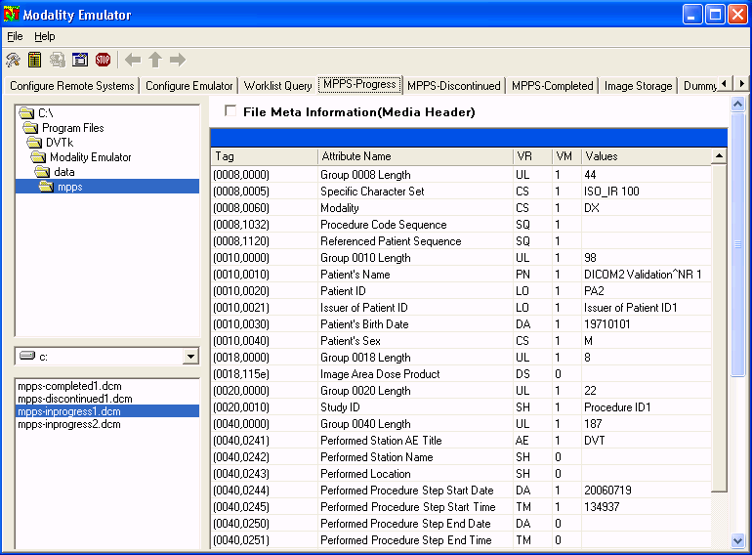

MPPS – Discontinued template
When the MPPS Discontinued tab is pressed, the screen at right-hand side is shown: | 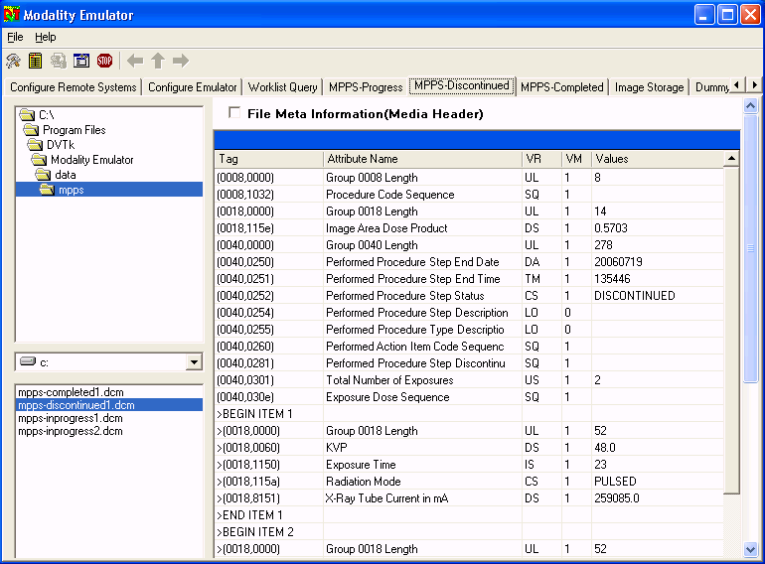

MPPS – Completed template
When the MPPS Completed tab is pressed, the screen at right-hand side is shown: | 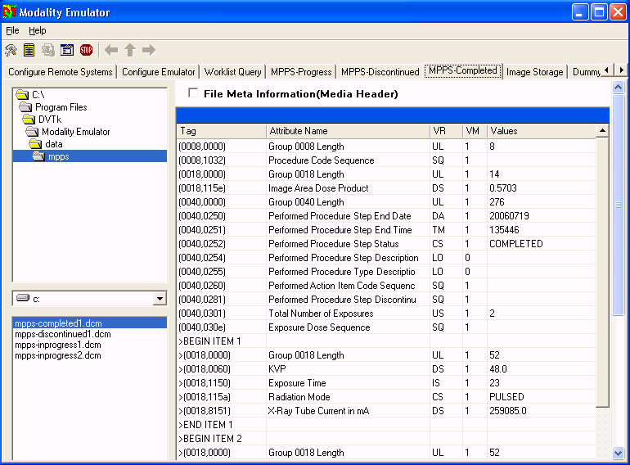

Image Storage
When the Image Storage tab is pressed, the screen at right-hand side is shown:  - The left-hand top-side is showing the directory where image files are located.  - All images in that directory will be send.  (see example screenshot below).  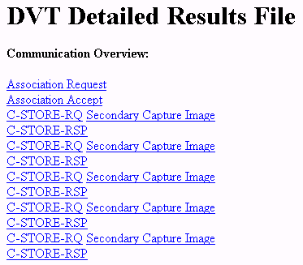 | 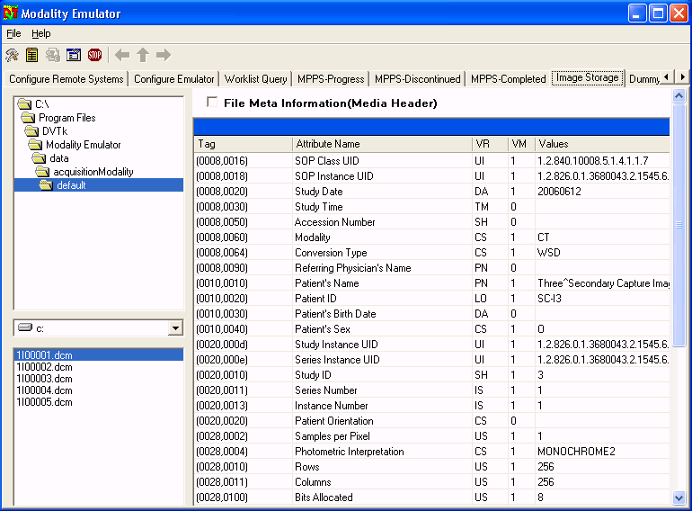

Perform DICOM actions
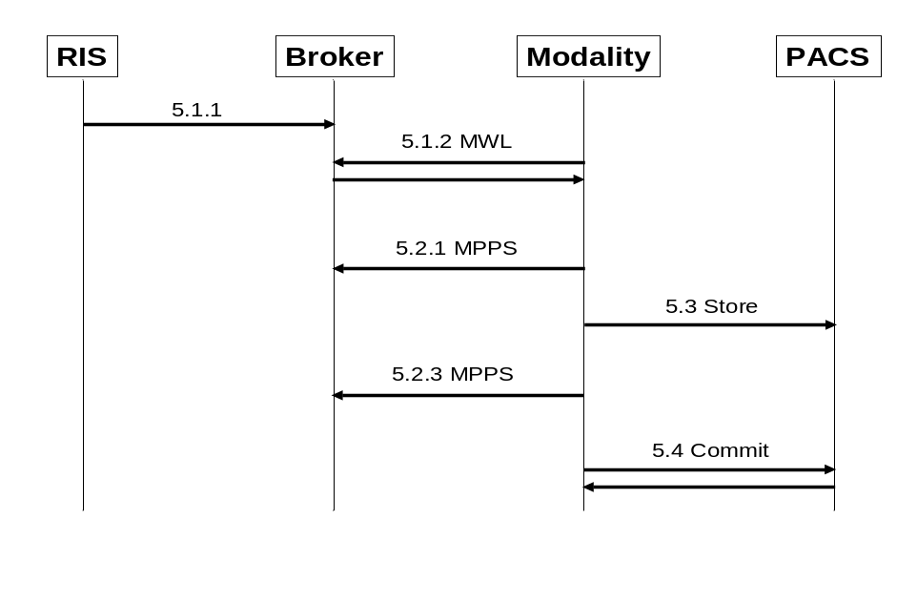

MWL - Worklist Query

Make a booking on the RIS first!
Before a Worklist query can be done, make sure that a patient is scheduled. The Booking must be done for the AET that has been done in step “Configure Emulator”.

Perform the MWL query
Press the button “Request Worklist”.
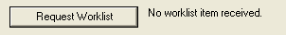

No Patients Found
When no patients are found, or the query failed, the screen below will be shown. The only patient shown, is the “Dummy Patient”.
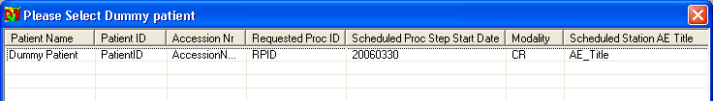

Select the “Dummy Patient” to continue. The text next to the Request Worklist button will indicate that no results have been found:

Patients Found
When the query results in one or more founds, the found names are listed, including the dummy patient.

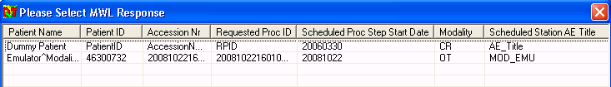

Select a patient to continue. The text next to the Request Worklist button will indicate the number of patients that match the query:
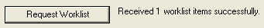

MPPS – Modality Performed Procedure Step

Progress
Press the button:
When the message has been send successfully, a return message is displayed:

Discontinued
Press the button:
When the message has been send successfully, a return message is displayed:

Completed
The button completed does not exist yet. You first need to send an image.
See next paragraph DICOM Store for the steps to store an image.

Press the button:
When the message has been send successfully, a return message is displayed:

DICOM Store

Press the button:
When the image has been send successfully, a return message is displayed:

Now the button MPPS completed button becomes available:

Storage Commit

Press the button:
When Storage Commitment has been successful, a return message is displayed:

Special usage

Extract the templates from a capture
Maybe the most powerful usage of the Modality Emulator is the ability to load parts of a capture file that you have made to analyze the behaviour of a specific modality.

DICOM Network Analyzer
The first step is to make a capture using DICOM Network Analyzer.
Change from Capture to analysis mode. Depending on what you have captured one or more streams must be visible:

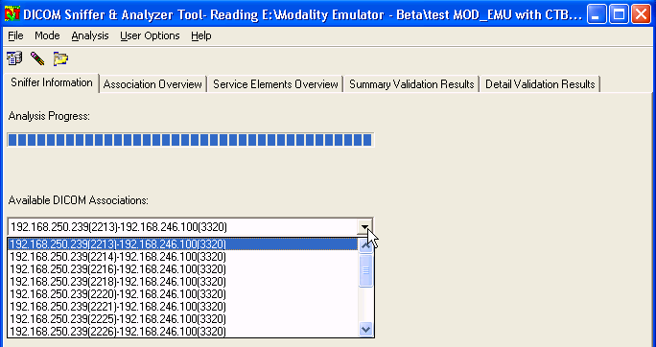

The paragraphs below describe how to extract the Worklist Query part and the MPPS messages.

MWL template
Assuming that a capture has been made, is loaded in DICOM Network Analyzer and you are looking at the program in analysis mode.

To be able to extract a MWL-template from the capture, it must be there! Search in the available DICOM Associations for the stream that contains “C_FIND_RQ” (below an example).

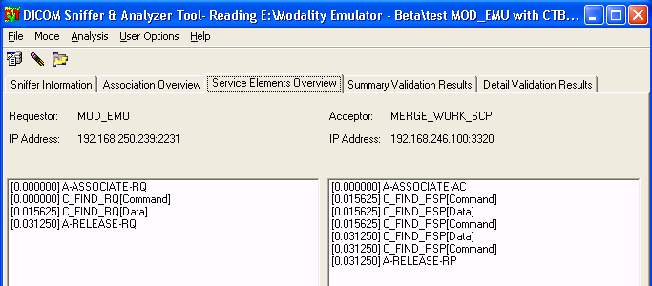

Right-click on the “C_FIND_RQ[Data]” and select “Save As File”:

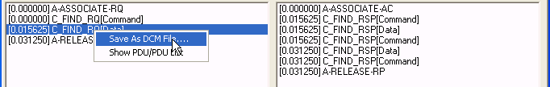

Navigate to a logical place and use a name that makes sense (e.g. US_HD11_WLM.dcm).

MPPS – N-Create
Repeat the steps as described for MWL.

To be able to extract a MPPS-template from the capture, it must be there! Search in the available DICOM Associations for the stream that contains “N_CREATE_RQ”.

Right-click on the “N_CREATE_RQ[Data]” and select “Save As DCM File”:

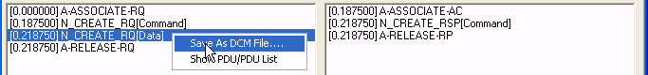

Navigate to a logical place and use a name that makes sense (e.g. US_HD11_MPPS_C.dcm).

MPPS – N-Get
Repeat the steps as described for MWL.

To be able to extract a MPPS-template from the capture, it must be there! Search in the available DICOM Associations for the stream that contains “N_SET_RQ” (below an example).

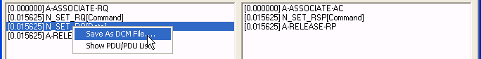

Navigate to a logical place and use a name that makes sense (e.g. US_HD11_MPPS_S.dcm).

Load the templates in the Emulator

Load MWL template
- Select the Worklist Query tab,  - Navigate to the location where the MWL template has been stored.  - Click the file. | 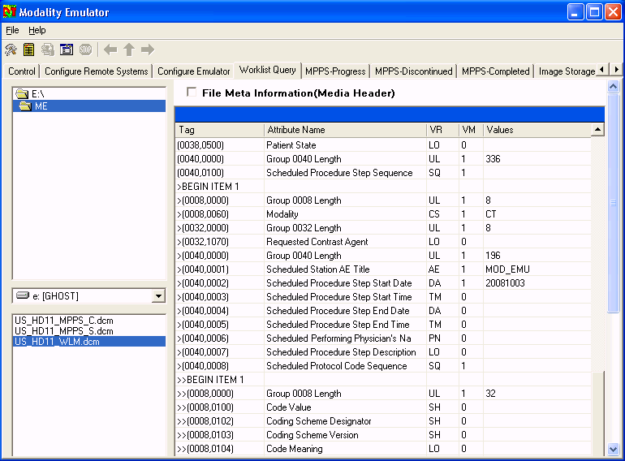

Load MPPS-Progress template
- Select the MPPS Progress tab,  - Navigate to the location where the MPPS template has been stored.  - Click the file. | 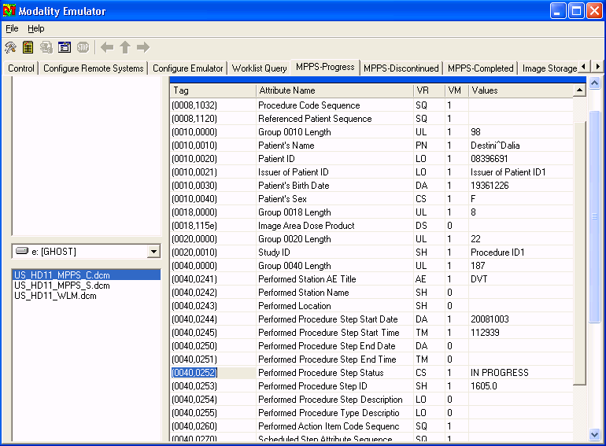

Load MPPS-Completed template
- Select the MPPS Completed tab,  - Navigate to the location where the MPPS template has been stored.  - Click the file. | 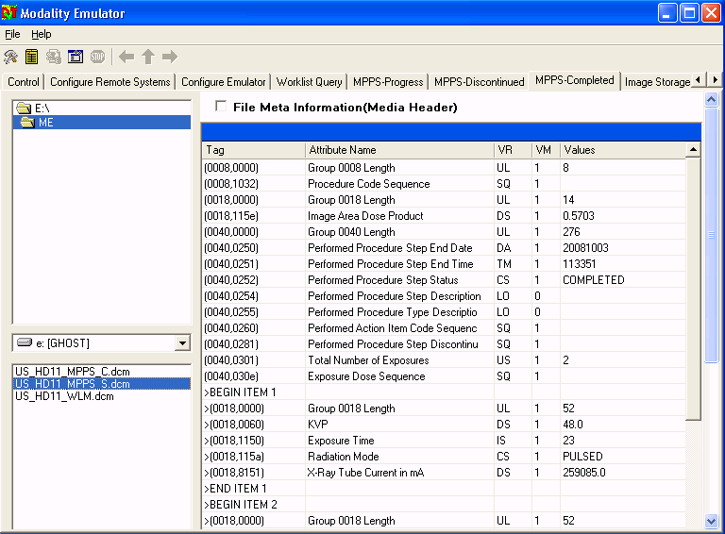

Mapping information
In Paragraph “6.1 Extract the templates from a capture” you have learned how to extract templates from a capture file. Next step is loading this template as “behaviour” for the Emulator. Now you may wonder why you want to store MPPS information of Mr. X while having Mr. Y in the Modality Emulator application! The overview below shows the re-mapping of the tool:
C-FIND-RSP: This is the response after a Modality Worklist Query
C-STORE: In the Modality Emulator these items are taken over from the C-FIND-RSP.
N-CREATE-RQ: In the Modality Emulator these items are taken over from the C-FIND-RSP.

CFINDRSP(Modality_Worklist_Information_Model_FIND)

SPECIFIC_CHARACTER_SET, CS
ACCESSION_NUMBER, SH
SCHEDULED_PROCEDURE_STEP_SEQUENCE, MODALITY, CS
REFERENCED_STUDY_SEQUENCE, SQ
PATIENTS_NAME, PN
PATIENT_ID, LO
PATIENTS_BIRTH_DATE, DA
PATIENTS_SEX, CS
STUDY_INSTANCE_UID, UI
REQUESTED_PROCEDURE_ID, SH
SCHEDULED_PROCEDURE_STEP_SEQUENCE, SCHEDULED_PROCEDURE_STEP_ID, SH
REQUESTED_PROCEDURE_DESCRIPTION, LO
SCHEDULED_PROCEDURE_STEP_SEQUENCE, SCHEDULED_PROCEDURE_STEP_DESCRIPTION, LO

CSTORERQ

SPECIFIC_CHARACTER_SET, CS
ACCESSION_NUMBER, SH
MODALITY, CS
REFERENCED_STUDY_SEQUENCE, SQ
PATIENTS_NAME, PN
PATIENT_ID, LO
PATIENTS_BIRTH_DATE, DA
PATIENTS_SEX, CS
STUDY_INSTANCE_UID, UI
REQUEST_ATTRIBUTES_SEQUENCE, REQUESTED_PROCEDURE_ID, SH
REQUEST_ATTRIBUTES_SEQUENCE, SCHEDULED_PROCEDURE_STEP_ID, SH
REQUEST_ATTRIBUTES_SEQUENCE, SCHEDULED_PROCEDURE_STEP_DESCRIPTION, LO
PERFORMED_PROCEDURE_STEP_ID, SH
PERFORMED_PROCEDURE_STEP_DESCRIPTION, LO

NCREATERQ(Modality_Performed_Procedure_Step)

SPECIFIC_CHARACTER_SET, CS
SCHEDULED_STEP_ATTRIBUTES_SEQUENCE, ACCESSION_NUMBER, SH
MODALITY, CS
SCHEDULED_STEP_ATTRIBUTES_SEQUENCE, REFERENCED_STUDY_SEQUENCE, SQ
PATIENTS_NAME, PN
PATIENT_ID, LO
PATIENTS_BIRTH_DATE, DA
PATIENTS_SEX, CS
SCHEDULED_STEP_ATTRIBUTES_SEQUENCE, STUDY_INSTANCE_UID, UI
SCHEDULED_STEP_ATTRIBUTES_SEQUENCE, REQUESTED_PROCEDURE_ID, SH
SCHEDULED_STEP_ATTRIBUTES_SEQUENCE, SCHEDULED_PROCEDURE_STEP_ID, SH
SCHEDULED_STEP_ATTRIBUTES_SEQUENCE, REQUESTED_PROCEDURE_DESCRIPTION, LO
SCHEDULED_STEP_ATTRIBUTES_SEQUENCE, SCHEDULED_PROCEDURE_STEP_DESCRIPTION, LO
PERFORMED_PROCEDURE_STEP_ID, SH
PERFORMED_PROCEDURE_STEP_DESCRIPTION, LO

DICOM attribute |  |  | Filling values for
TAG | DICOM Item | VR | MWL retrieved | Store | MPPS
0008,0005 | SPECIFIC CHARACTER SET | CS | Source | Copy | Copy
0008,0050 | ACCESSION NUMBER | SH | Source | Copy | Copy
0008,1110 | REFERENCED STUDY SEQUENCE | SQ | Source | Copy | -
0010,0010 | PATIENTS NAME | PN | Source | Copy | Copy
0010,0020 | PATIENT ID | LO | Source | Copy | Copy
0010,0030 | PATIENTS BIRTH DATE | DA | Source | Copy | Copy
0010,0040 | PATIENTS SEX | CS | Source | Copy | Copy
0020,000D | STUDY INSTANCE UID | UI | Source | Copy
0032,1060 | REQUESTED PROCEDURE DESCRIPTION | LO | Source
0040,0253 | PERFORMED PROCEDURE STEP ID | SH |  | Copy | Source
0040,0254 | PERFORMED PROCEDURE STEP DESCRIPTION | LO |  | Copy | Source
0040,0270  -> 0008,0050 | SCHEDULED STEP ATTRIBUTES SEQUENCE  ACCESSION NUMBER | SQ  SH | Source |  | Copy from source 0008,0050
0040,0270  -> 0008,1110 | SCHEDULED STEP ATTRIBUTES SEQUENCE  REFERENCED STUDY SEQUENCE | SQ  SQ | Source |  | Copy from source 0008,1110
0040,0270  -> 0020,000D | SCHEDULED STEP ATTRIBUTES SEQUENCE  STUDY INSTANCE UID | SQ  UI | Source |  | Copy from source 0020,000D
0040,0270  -> 0040,1001 | SCHEDULED STEP ATTRIBUTES SEQUENCE  REQUESTED PROCEDURE ID | SQ  SH | Source |  | Copy from source 0040,1001
0040,0270  -> 0040,0009 | SCHEDULED STEP ATTRIBUTES SEQUENCE  SCHEDULED PROCEDURE STEP ID | SQ  SH | Source | - | Copy from source 0040,0009
0040,0270  -> 0032,1060 | SCHEDULED STEP ATTRIBUTES SEQUENCE  REQUESTED PROCEDURE DESCRIPTION | SQ  LO | Source |  | Copy from source 0032,1060
0040,0270  -> 0040,0007 | SCHEDULED STEP ATTRIBUTES SEQUENCE  SCHEDULED PROCEDURE STEP DESCRIPTION | SQ  LO | Source |  | Copy from source 0040,0007
0040,0275  -> 0040,1001 | REQUEST ATTRIBUTES SEQUENCE  REQUESTED PROCEDURE ID | SQ SH | Source | Copy from source 0040,1001
0040,0275  -> 0040,0009 | REQUEST ATTRIBUTES SEQUENCE  SCHEDULED PROCEDURE STEP ID | SQ SH | Source | Copy from source 0040,0009
0040,0275  -> 0040,0007 | REQUEST ATTRIBUTES SEQUENCE  SCHEDULED PROCEDURE STEP DESCRIPTION | SQ LO | Source | Copy from source 0040,0007
0040,1000  -> 0008,0060 | SCHEDULED PROCEDURE STEP SEQUENCE MODALITY  MODALITY | SQ  CS | Source | Copy | Copy
0040,1000  -> 0040,0009 | SCHEDULED PROCEDURE STEP SEQUENCE  SCHEDULED PROCEDURE STEP ID | SQ SH | Source | Copy | Copy
0040,1000  -> 0040,0007 | SCHEDULED PROCEDURE STEP SEQUENCE  SCHEDULED PROCEDURE STEP DESCRIPTION | SQ LO | Source | Copy | Copy
0040,1001 | REQUESTED PROCEDURE ID | SH | Source

